Application and evaluation of a K-Medoids based shape clustering method for an articulated design space

In this paper author is grouping similar shapes into same cluster by using K-Medoids clustering algorithm. In design space systems consists of several shapes and identifying which data is related to which shape is difficult and to overcome from this problem author giving all shapes files to K-Medoids clustering algorithm and this algorithm will use Hamming distance to find distance between different pairs of data and then apply K-Medoids clustering which will cluster design shape into different clusters. It will put same or similar shape data into same cluster and then we can visualize each cluster to view different shapes available in data files.

To implement this project author has used some shapes dataset but not publish that dataset on the internet and no such dataset also available so from KAGGLE I downloaded 4 different shapes dataset which contains CIRCLE, STAR, TRIANGLE and RECTANGLE and this shapes will be input to K-Medoids to arrange similar shapes in same cluster.

Below is the shapes dataset used in this project

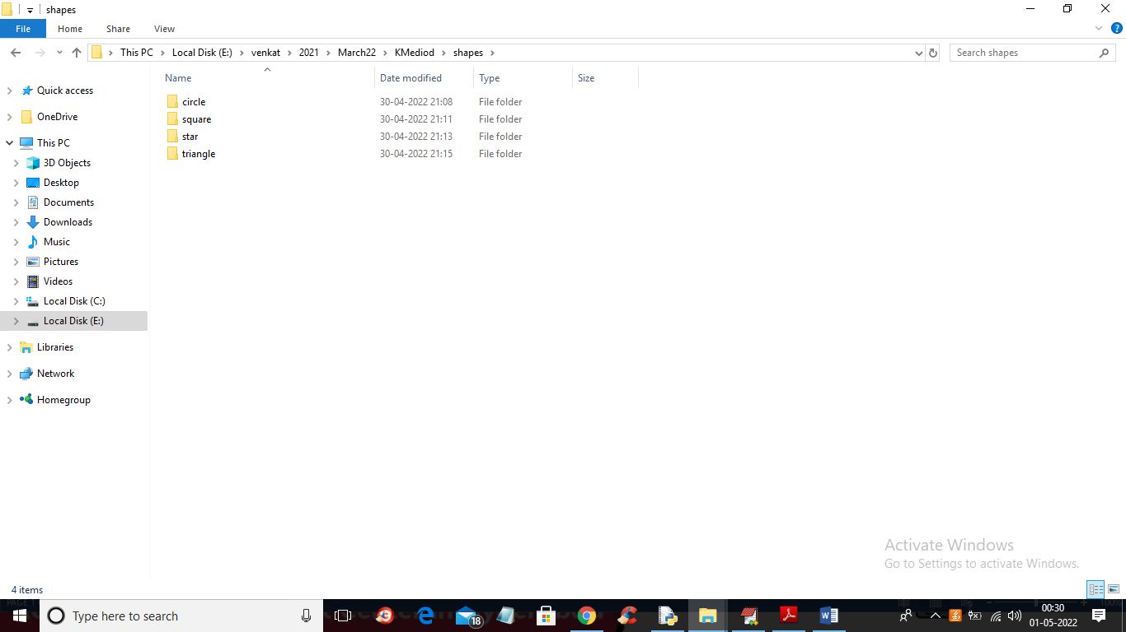

In above screen we have 4 different shapes and just go inside any folder to view that shapes like below screen

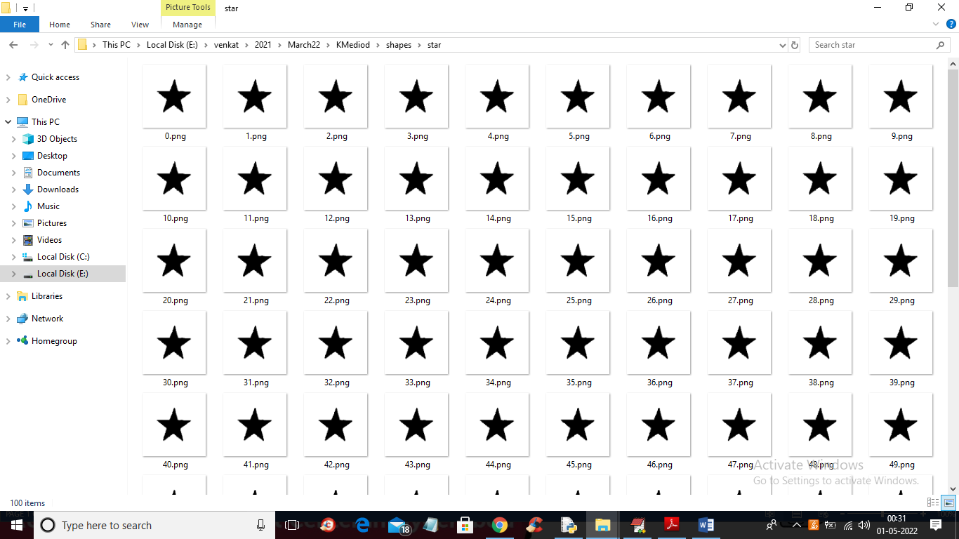

In above screen we can see shapes available in dataset.

To implement this project we have designed following modules

1. Upload Shapes Dataset: using this module we will upload shapes dataset to application
2. Preprocess & Hamming Distance Calculation: using this module we will read all shapes and then normalize shapes values between 0 and 1 and then calculate hamming distance between each shape
3. Run K-Medoids Clustering Algorithm: now K-Medoids will use Hamming distance and Euclidean distance to find closeness between different shapes and then put same shape in same cluster and this continues till no more data can be arranged in clusters
4. Similar Shapes Visualization from Clusters: using this module we will visualize all similar shapes available in all clusters

SCREEN SHOTS

To run project double click on ‘run.bat’ file to get below output

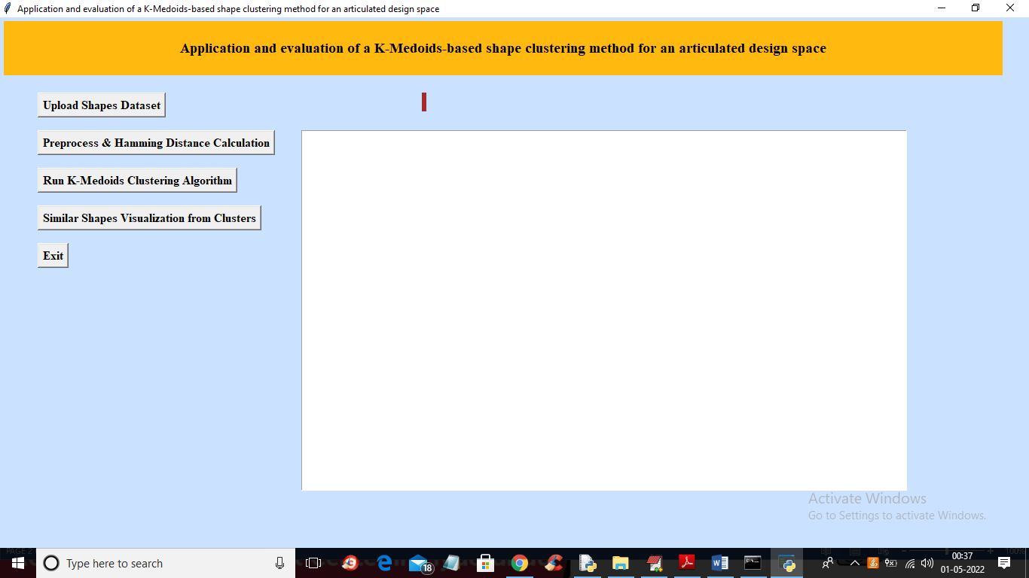

In above screen click on ‘Upload Shapes Dataset’ button to upload shapes to application

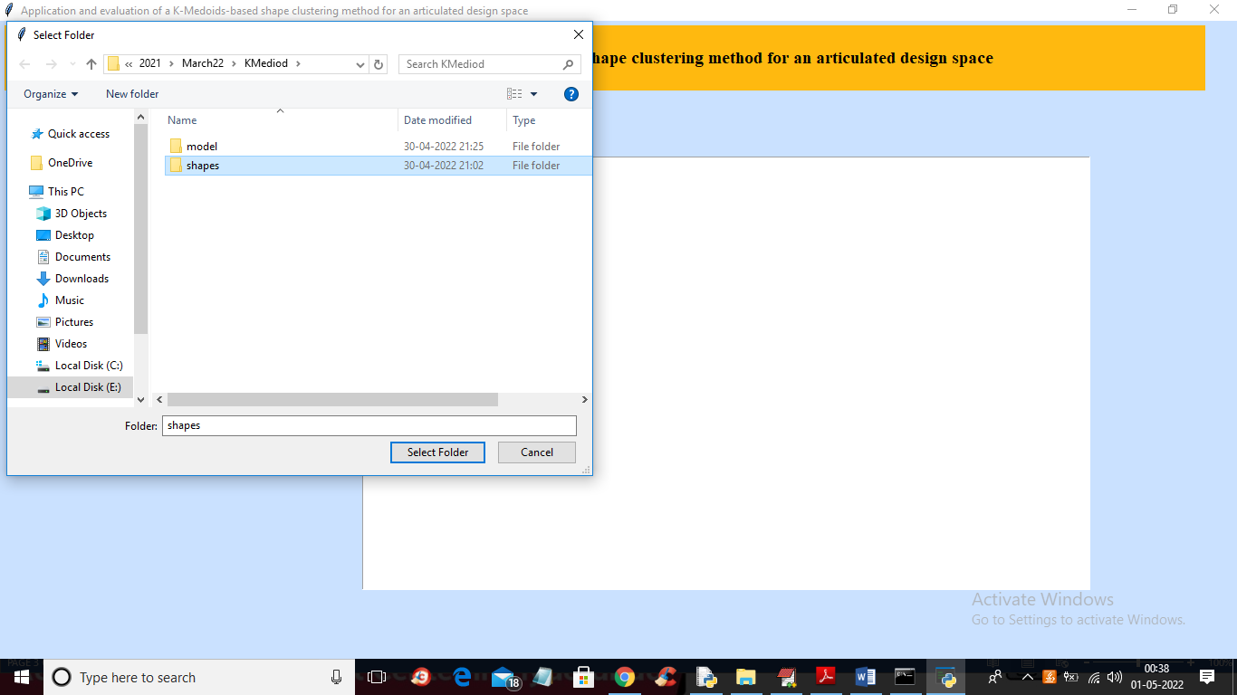

In above screen selecting and uploading ‘shapes’ folder and then click on ‘Select Folder’ to load dataset and get below output

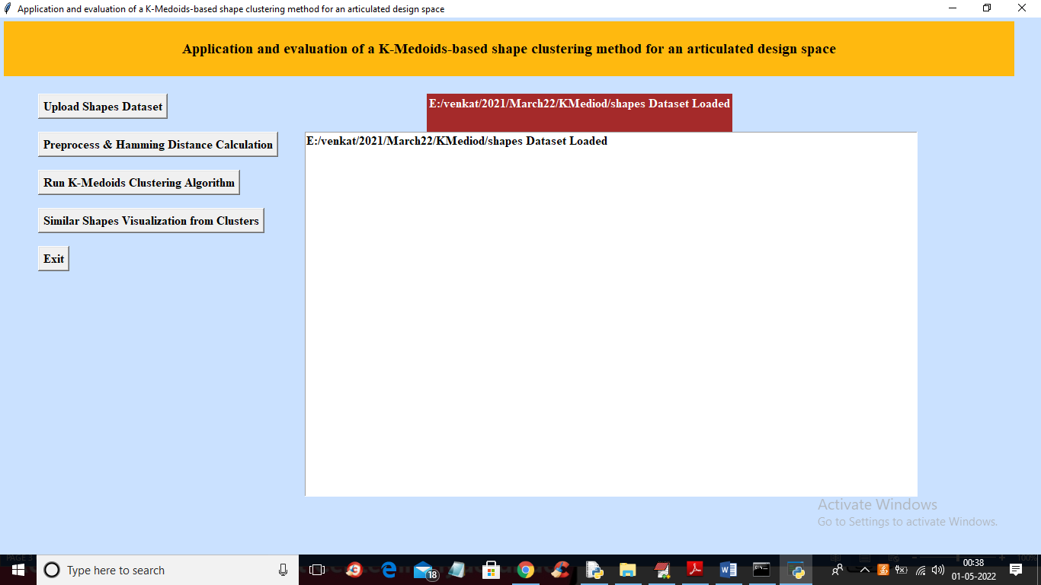

In above screen dataset loaded and now click on ‘Preprocess & Hamming Distance Calculation’ button to read all shapes and then compute hamming distance

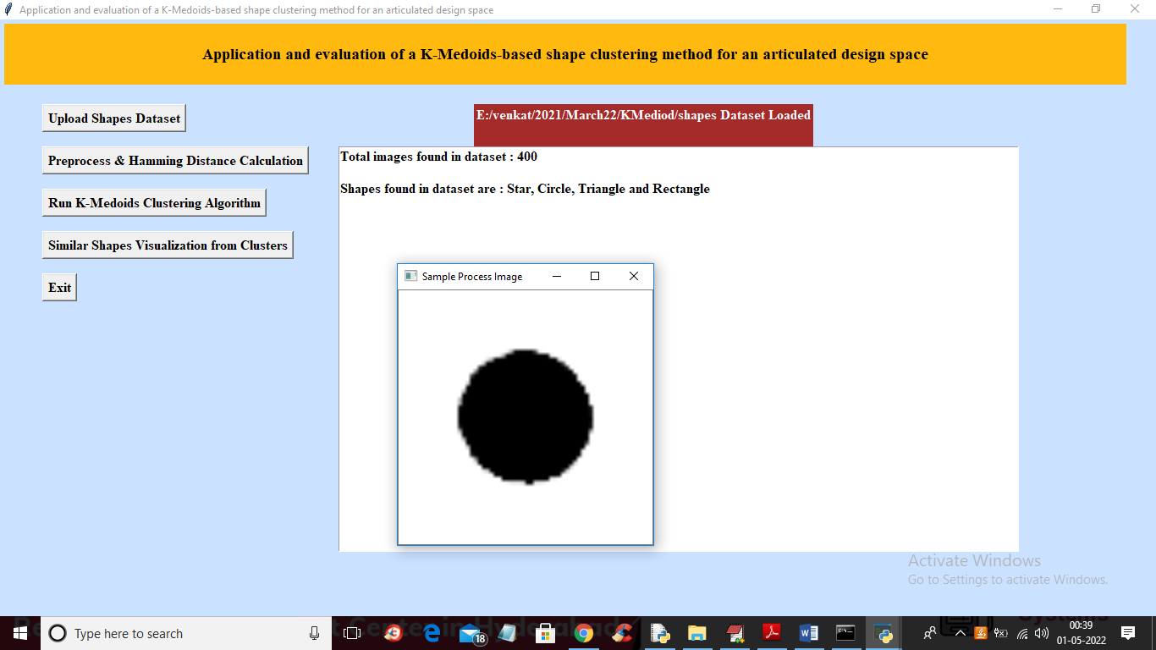

In above screen all shapes are processed and saved in application memory with hamming distance and we can see dataset contains 400 shapes of different shapes types and to check weather shapes are processed properly or not so I am displaying one sample processed image and now close above image and then click on ‘Run K-Medoids Clustering Algorithm’ button to cluster all shapes and get below output

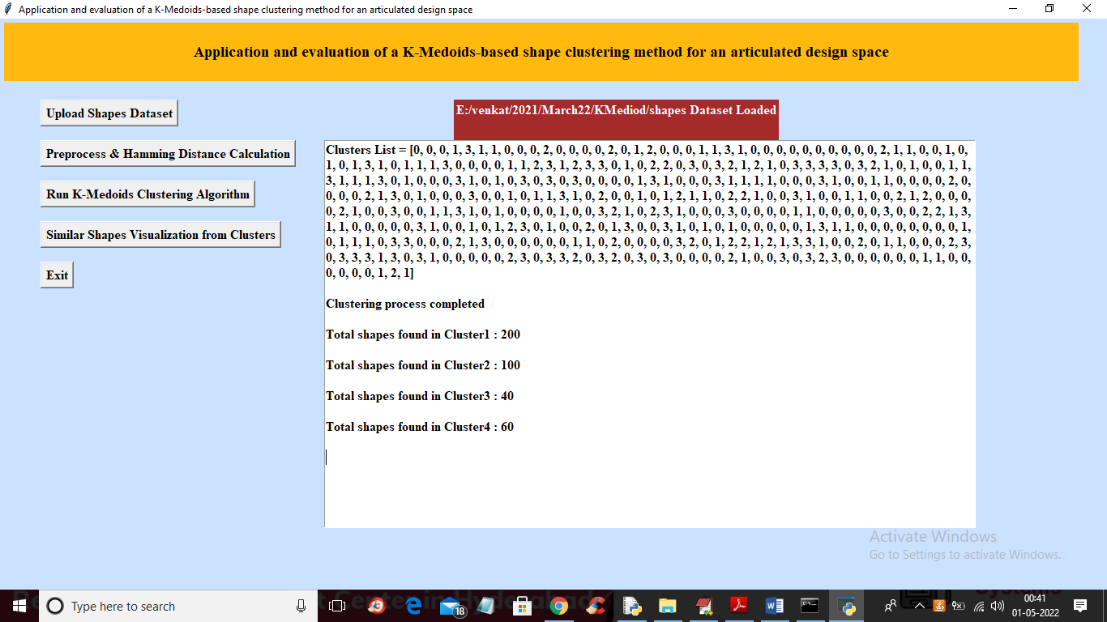

In above screen we can see clustering process completed and in cluster list we can see which record is went to which cluster for example shape or record 1 goes to cluster and we can see all shapes are arranged between cluster 0 to 3 and then we can see how many shapes are arranged in each cluster and now click on ‘Similar Shapes Visualization from Clusters’ button to visualize shapes in different clusters

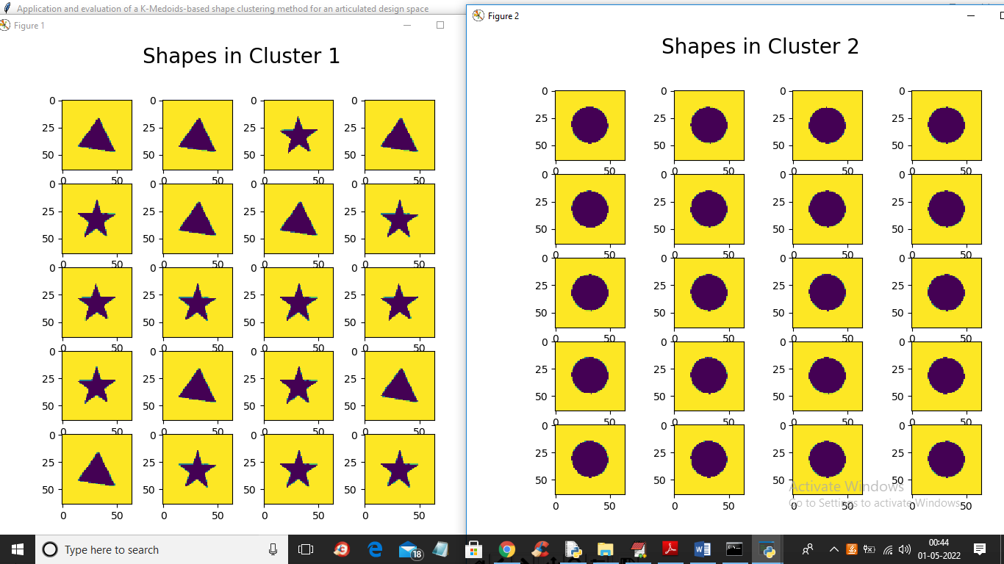

In above screen we can see cluster 1 contains all triangles and stars shapes (here triangle and start is having little similarity in shapes) and cluster 2 contains all circles shapes and below is 3rd and 4th cluster shapes output

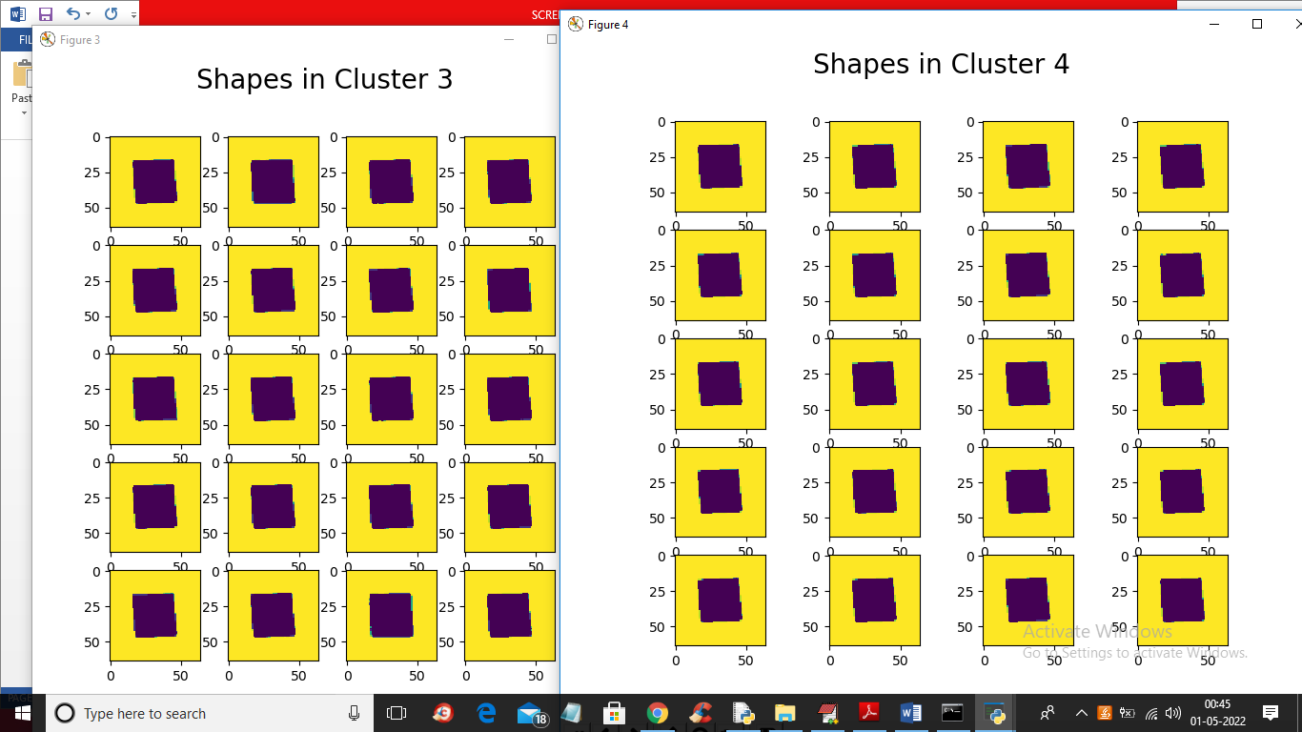

In above screen clusters 3 and 4 contains similar shape called Rectangle and in below screen from paper we can see different shapes exists in same cluster

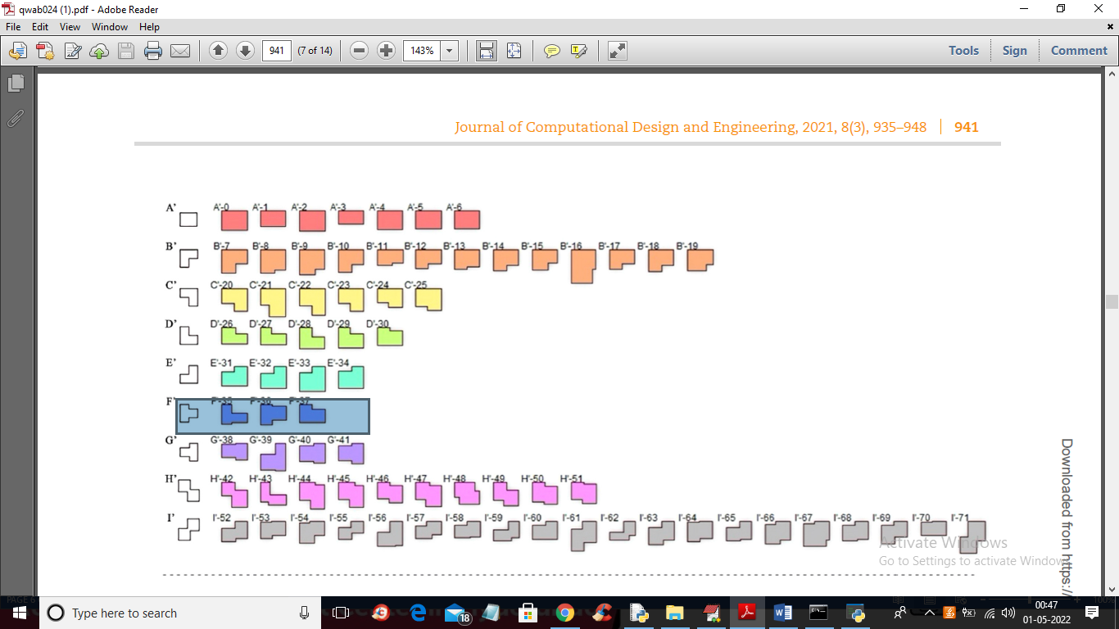

In above screen from paper we can see cluster F contains different shapes which look little similar.

The main aim of the project is to group same shapes in to same cluster